

COLLEGE CODE : 3114

COLLEGE NAME : MEENAKSHI COLLEGE OF ENGINEERING

DEPARTMENT : CSE (AI&ML)

ROLL NO :311423148039

PROJECT NAME :WEATHER IMPACT ANALYSIS IN CROP MONITORING AND PEST MANAGEMENT

SUBMITTED BY,

NAME: HARINI. E

TEAM MEMBERS NAME;

1.PRABHA. L

2.PRIYA DHARSHINI. R

3.SANDHIYA.M

4.SAI CHANDINI. P

WEATHER IMPACT ANALYSIS IN CROP MONITORING AND PEST MANAGEMENT

OUTPUT LINK OF THE PROJECT STIMULATION:

<https://wokwi.com/projects/430904918314288129>

SCREENSHOT OF THE PROJECT OUTPUT:

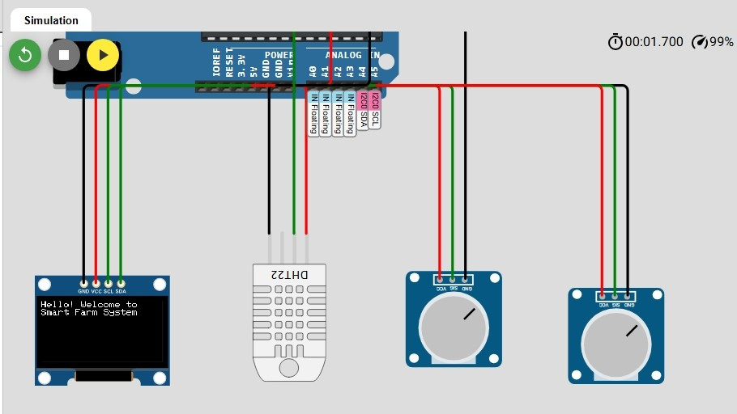

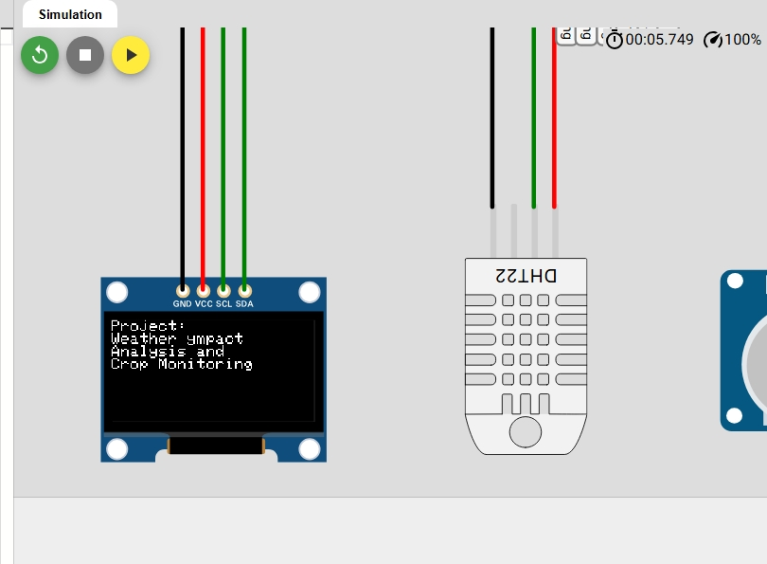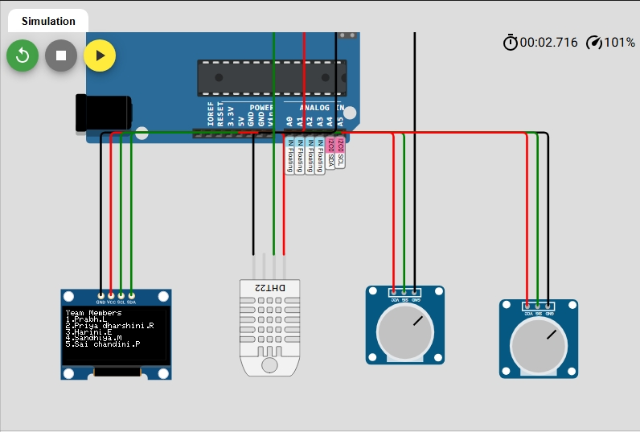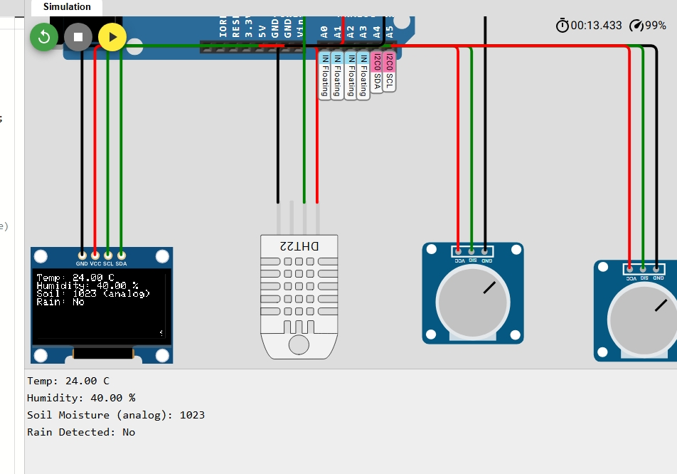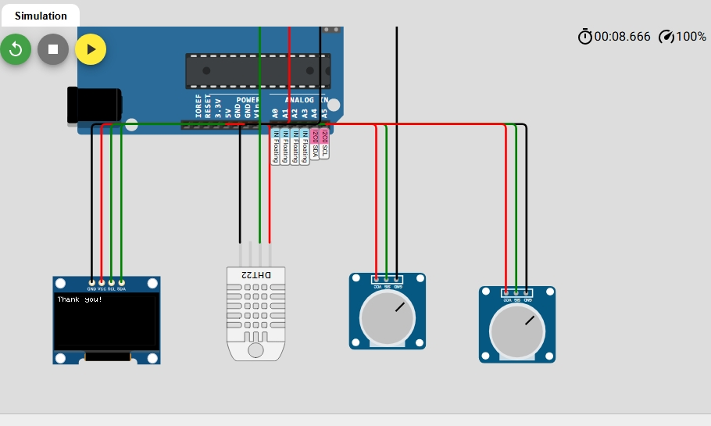

OUTPUT SHOWN THROUGH WEBSITE:

